**Difference Between Arduino Uno and Mega 2560**

**Microcontrollers:**

Arduino Mega

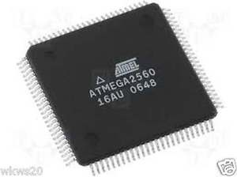

Arduino Mega uses an ATmega2560 microcontroller which has:

* 256K Bytes of In-System Self-Programmable Flash.
* 8K Bytes RAM.
* 4K Byte Internal SRAM.

Arduino Uno

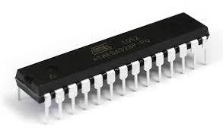

Arduino Uno uses an ATmega328p microcontroller which has:

* Flash Program Memory: 32 k bytes.
* EEPROM Data Memory: 1 k bytes.
* SRAM Data Memory: 2 k bytes.

**Boards:**

Arduino Mega

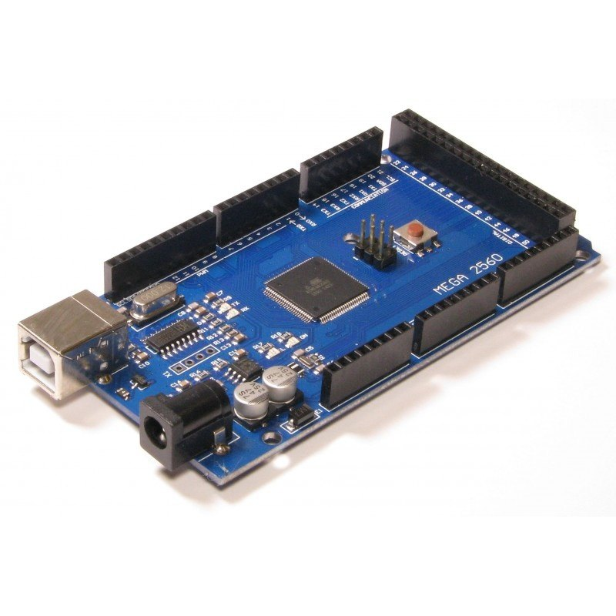

Arduino Mega board has:

* 54 digital I/O pins, of which 14(D0 to D13) can be used as PWM outputs.
* 16 analog input pins, which can also be used as digital I/O pins, adding to the existing 54 digital I/O pins.
* 4 serial communication lines(pins D0, D1, and from D14 to D19).

Arduino Uno

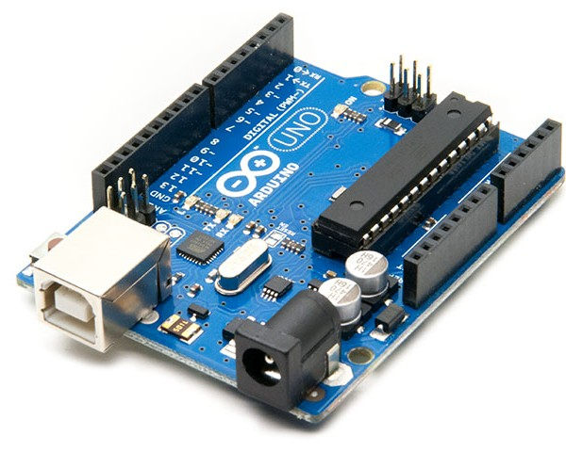

The Arduino Uno board has:

* 14 digital I/O pins, of which 6 (D3, D5, D6, D9, D10, and D11) can be used as PWM outputs.
* 6 analog inputs, which can also be used as digital I/O pins, adding to the existing 14 digital I/O pins.
* Only one serial communication line (D0, D1).

**Final points to remember while selecting one of these:**

* An Arduino Uno board is best suited for beginners who have just started using microcontrollers, on the other hand, Arduino Mega board is for enthusiasts who require a lot of I/O pins for their projects.
* The shield which are physically compatible with Arduino Uno are also compatible with Arduino Mega like this motor driver shield:

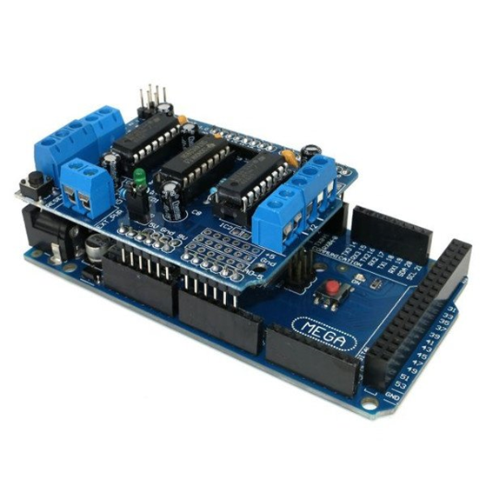

* Due to smaller size of the Arduino Uno than Arduino Mega, it can be use to make more compact projects, although boards like the Arduino Micro or the Arduino Nano are recommended for that purpose.